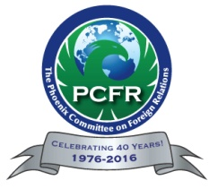
12th Annual International State of the State Luncheon: A Discussion with Governor Doug Ducey:
Arizona’s Global Future in Changing Times

Thursday, May 4, 2017 – Luncheon Meeting

Registration: 11:00am Lunch: 11:30am Program: 12:00pm – 1:00pm

The Sheraton Grand Phoenix – 340 N. 3rd Street, Phoenix, AZ 85004

China Over the Next Five Years
Phoenix Committee on Foreign Relations

Date:

Time:

Location:

Thank you to our Event Sponsors:

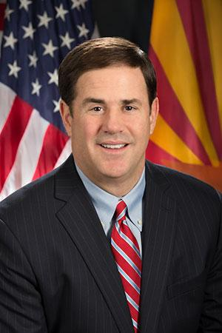
The 2017 International State of the State Luncheon, to be held at the Sheraton Grand Phoenix on May 4th, continues to build on the themes of international economic, business and political engagement between Arizona and the world. Please save the date for an insightful dialogue with Governor Doug Ducey at this year's International State of the State Luncheon hosted by the Phoenix Committee on Foreign Relations.

Governor Doug Ducey was elected on November 4, 2014 and was sworn into office on January 5, 2015, becoming Arizona’s 23rd Governor.

As governor, Ducey’s priorities are growing the economy, creating jobs, improving outcomes in K-12 education and balancing the budget. A champion of limited government, economic development and Arizona businesses and families, Governor Ducey has pledged to work every day to ensure “Opportunity for All.”

Prior to taking his oath as governor, Ducey served as Arizona’s 32nd state treasurer, a position he held since his oath of office in January 2011. As Arizona’s chief banker and investment officer, Ducey managed more than $13 billion in state assets and served as an investment manager for local governments. He also served as chairman of Arizona’s State Board of Investment and State Loan Commission, as Arizona’s Surveyor General and was a member of the State Land Selection Board.

Thank you to our Collaborating Organizations:
Arizona District Export Council, Canada Arizona Business Council, Greater Phoenix Economic Council, Los Abogados, O’Connor Institute, United Nations Association
COST:
$65 for Members (received before 05/01/17, add $10 for reservations after 05/01/17);
$80 for General Public (received before 05/01/17, add $10 for reservations after 05/01/17).
GET YOUR REGISTRATION IN EARLY, AS THIS VENUE HAS LIMITED SEATING

TO REGISTER:
ONLINE AT www.pcfraz.org – If you are a PCFR Member select “PCFR Member Online Registration”. If you are a Non-Member, Select “General Public Online Registration”.
MAIL REGISTRATION with check to: PCFR, 7949 E. Acoma Drive, #207, Scottsdale, AZ 85260
FAX with credit card information to: (480) 289-5765
E-MAIL with credit card information to: conni@pcfraz.org
Questions? Call (602) 441-4967

PCFR MEMBER ($65):
Name: ____________________________________________ Title: ______________________________________

Company: _____________________________________________________________________________________
Phone: ( ) _______________________ Fax: ( ) _____________________ Email*: _____________________

**Please provide an email address so that we may send your confirmation.
If you are inviting a guest, please complete this entire form with their information.
Completing the form in advance will expedite check-in at the door.

GENERAL PUBLIC ($80)
Name: ________________________________Title AND Co: ______________________________________________
(We need this information to complete a proper name badge for your guest. Thank you.)
Address: ________________________________________________________________________________________
City: ____________________________________ State: _______________ Zip: __________________________________
Phone: ( ) _______________________ Fax: ( ) _____________________ E-mail: ______________________
______ Yes! We would like a SPONSORSHIP TABLE for 10 people for $1,000. Please forward this form to reserve my table. See table sponsorship below. Tables located on a “first-come, first-paid” basis.
Please check – Method of Payment:
[ ] $65 Members (Early Bird) [ ] 75 General Admission/Guest (Early Bird)
[ ] $80 Members (After 05/01/17) [ ] $90 General Admission/Guest (After 05/01/17)
[ ] $1,000 Table Sponsorship for 10
[ ] Please charge the credit card below. [ ] Check enclosed payable to PCFR.
Card No. ___________________________ Name: __________________________________________
Expiration Date __________________ Signature: _______________________________________
CVV (Security Code) __________________
Total Payment $ __________ Visa, MasterCard, American Express, Checks and Cash accepted
Mailing Address:
Phoenix Committee on Foreign Relations
7949 E. Acoma Drive #207
Scottsdale, AZ 85260
www.pcfraz.org
Phone: 602-441-4967 Fax: 480-289-5765 E-Mail: conni@pcfraz.org
There are no refunds for reservations canceled within 72 hours of the event.

Phoenix Committee on Foreign Relations May 4, 2017 Meeting Notice
Early Bird Registration is by May 1, 2017

