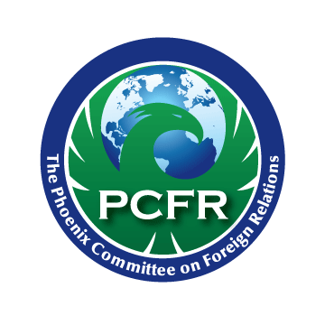

Phoenix Committee
on Foreign Relations

Student Fellows

Program Guidelines

PCFR’s Student Fellows (PSF) Program is designed to provide graduate students who are focused on international-related businesses/industries and hope to stay in the metro Phoenix area following completion of their degree with the opportunity to become intimately involved with the mission and programs of PCFR.

Fellows have the opportunity to be a member for up to two years if they are in good standing after the first year, with the ability to attend programs at no charge. This membership is highly selective and is only open to one student per target institution per year. Students who hope to become a Fellow are encouraged to engage with PCFR by attending events at the student rate, and by working with their PCFR representatives at their home institution. If selected, a PCFR Student Fellow is expected to:

- Contribute to the mission of PCFR.

- Participate in meetings. At each meeting, a fellow will be selected to sit at the head table (as available), interact with our featured guest, and following the event, provide a summary of the evening and related discussion.

- Actively contribute to a deliverable item, as managed by the PSF coordinator that contributes to the mission of PCFR. Projects will be briefed to the PCFR Board at the completion of the season.

  - Deliverable items for the 2016-2017 year have included:
    - Creation of a formal internship program for undergraduates who want to get more involved in PCFR and assist with event coordination and other tasks
      - One internship project thus far has been the creation of a Student Opportunities page on the PCFR website that describes student event attendance rates, the internship program, and the PSF program.
    - Building connections between PCFR and like-minded organizations such as ASU, Global Ties Arizona, Phoenix Sister Cities, and others,
    - Securing additional involvement of global companies such as Intel, Avnet, and others in the activities of PCFR.

- Stay in touch between meetings. There is a PSF coordinator. You are expected to stay in contact with this coordinator between and at meetings. Reaching out to other Student Fellows during the fellowship term is highly encouraged.

- Proactively engage in the membership, including, but not limited to:

- Introducing yourself to the membership at a meeting during the season.
- Mix and mingle with the members.
- Reach out to other members that may be of interest to you and your major.
- Communicate to the PSF coordinator what your interests are, and how we can help you achieve your goals.

- Interface with one of the PCFR committees—Membership, Program (incl. Reading Group), Outreach, or PR—to provide assistance based on your skillset and expertise
- Coordinate updates for the monthly Member Muse newsletter, which may include interviewing current members and highlighting their experiences in the newsletter and on the PCFR website.

- Have a high probability of staying in Phoenix and look to become a Young Professional member upon completion of your studies.

9. Give feedback on ways the program can be improved.

Agreed to by: ___________________________________________Date: ___________

