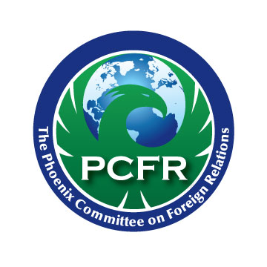  2016-2017 Board  Co-Chairmen  Keith Galbut, Esq.  Galbut & Galbut, P.C.  Paul G. Johnson, Esq.  Jennings Strouss & Salmon  President  Melissa Sanderson  Freeport McMoRan Inc.  Vice President  Brett W. Johnson, Esq.  Snell & Wilmer, LLP  Secretary/Treasurer  Karen Gill Meyer  Morgan Stanley  Directors  Paul Arutt  Heritage West Capital Corp.  Susan Assadi  GAPR  Matthew Apfel  Apfel and Associates  Diana Bullen  Mesa Community College  Ambassador (ret.) Douglas A.  Hartwick, Consultant  Andrew Jaynes, ASU  Center for Law & Global Affairs  Joan Jordan  Sanford Rose Associates  Claire Merkel  The McCain Institute  Michael Patterson  Polsinelli  Steven Ranes  Arizona Public Service  Mark Roberts  Alliance Bank of Arizona  Steve Rodis  Wallace, Plese + Dreher, LLP  Sarah Suggs  The O’Connor Institute  Lorianne Taitano  Salt River Project  Ex-Officio Board Members  Barbara Dawson  Snell & Wilmer LLP  Douglas Sylvester  ASU College of Law  Emeritus Board Members  Olivier Beabeau  Ed Kirdar  Stephen MacKinnon  JP Millon  Shoshana Tancer  Membership Chair  Steven Ranes  Program Chair  Andrew Jaynes  Executive Director  Conni Ingallina  7949 E. Acoma Drive, #207  Scottsdale, AZ 85260  - 602.441-4967  Fax: 480.289.5765  conni@pcfraz.org  www.pcfraz.org | Dear PCFR Member:  As you know, PCFR is a 501c3 nonprofit organization dedicated to improving understanding of international issues here in Arizona. As THE premier foreign policy organization, it is our job to spread the word through our speakers, programs and topical lunches on issues of international importance.  Last year we hit a milestone – 40 years of promoting foreign policy here in Arizona. What a milestone! We are positioned to continue another 40 years and beyond and are excited about the direction we are going.  Having said that, it’s a good reminder that we are a 501c3 nonprofit and therefore a place to remember when you are thinking about your charitable contributions for the year. We started to think about how to make this option more available to our members we created the PCFR BENEFACTOR program.  The purpose of the PCFR Benefactor Program is to insure fiscal longevity for PCFR while at the same time recognizing those members who have made a long-term commitment to our organization.  The program consists of a monetary gift that will be used in part for a long-term funding pool and in part for ongoing operational needs. The minimum gift is $3,000, with no upper limit of how much a donor may wish to give. This gift may be broken up into two payments of 50% of the gift over 2 years.  This gift is 100% tax deductible and has the following benefits for five years:  - Recognition in PCFR organization materials.  - Recognition on the PCFR website.  - Recognition at regular meetings and special meetings.  - Recognition in the Member Muse as a featured member.  The donation will be distributed as follows:  - 10% of the full contribution each year for 5 years;  - the other 50% may be designated by the donor for speakers, PCFR Fellows, new initiatives, memberships, general fund, etc., so the person may direct it toward something of interest.  Although you may not have thought about giving before, we hope you will consider a one-time gift that will help insure the continued good work of the PCFR.  If you have any questions, please contact myself or Conni.  Thank you for your ongoing support and consideration,  Brett  Brett Johnson  PCFR President

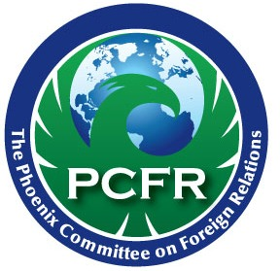
PCFR Benefactor Program

The purpose of the PCFR Benefactor Program is to insure fiscal longevity for PCFR while at the same time recognizing those members who have made a long-term commitment to our organization.
The program consists of a monetary gift that will be used in part for a long-term funding pool and in part for ongoing operational needs. The minimum gift is $3,000, with no upper limit of how much a donor may wish to give. This gift may be broken up into two payments of 50% of the gift over 2 years.
This gift is 100% tax deductible and has the following benefits for five years:
- Recognition in PCFR organization materials.
- Recognition on the PCFR website.
- Recognition at regular meetings and special meetings.
- Recognition in the Member Muse as a featured member.
The donation will be distributed as follows:
- to general fund at a rate of 10% of the full contribution each year for 5 years;
- the other 50% may be designated by the donor for speakers, PCFR Fellows, new initiatives, memberships, etc., so the person may direct it toward something of interest;
- it may be designated towards the general fund as well.
****************************************************************************
BENEFACTOR INFORMATION:
Name: _________________________________________Company _______________________________________
Address: _______________________________________City, State & Zip: __________________________________
Telephone: _____________________________________E-Mail: __________________________________________
PAYMENT INFORMATION: Payment in 1 Year: _______ Payment in 2 Years: _____________
For Season: ___________________
Amount enclosed $ Check #
Send checks to: PCFR, 7949 E. Acoma Drive, Suite 207, Scottsdale, AZ 85260
Credit Card Type: (circle one) MC VISA AMEX
Name on Card ______________________________________
Credit Card # _______________________________________Exp __________ Sec Code ______

